“**Spread A Smile”**

**A Food Donating App**

A Socially Relevant Project-I Report submitted to

JAWAHARLAL NEHRU TECHNOLOGICAL UNIVERSITY ANANTAPUR.

In Partial Fulfillment of the Requirements for the Award of the degree of

BACHELOR OF TECHNOLOGY IN

COMPUTER SCIENCE AND SYSTEMS ENGINEERING

BY

| **Shaik Rahiz Basha** | **19121A15A2** |
| --- | --- |
| **Pujari Hari** | **19121A1585** |
| **Suhaas P** | **19121A15A5** |
| **Ramayanam Girish** | **19121A1589** |
| **Pavan Kumar Raju** | **19121A1596** |

Under the Guidance of

**Dr.Cuddapah Anitha**

Associate Professor

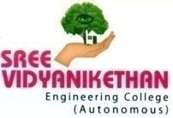

Department of Computer Science and Systems Engineering

# SREE VIDYANIKETHAN ENGINEERING COLLEGE

(Affiliated to JNTUA, Anantapuramu) Sree Sainath Nagar, Tirupathi – 517 102 2021-2022

**DEPARTMENT OF COMPUTER SCIENCE AND SYSTEMS ENGINEERING**

**VISION AND MISSION**

**VISION**

### To become a Center of excellence in Computer Sciences and Systems Engineering through Teaching, Training and Innovation to produce high quality engineering professionals who can solve the growing complex problems of the society and industry.

**MISSION**

* **Established with cause of development of Technical education in advanced Computers Sciences and Systems Engineering with applications to systems thereby serving the society and Nation.**
* **Transfer of knowledge through contemporary curriculum and fostering faculty and student development.**
* **Create keen interest for research and innovation among students and faculty by understanding the needs of the society and industry.**
* **Skill Development among diversity of students in technical domains and profession for development of systems and processes to meet the demands of the industry and research.**
* **Imbibing values and ethics in students for prospective and promising engineering and develop a sense of respect for all.**

## Program Educational Objectives (PEO’s)

**After few years of graduation, the graduates of B.Tech(CSSE) will:**

| 1. | Demonstrate competencies in the Computer Science domain and Management  with an ability to comprehend, analyze, design and create software systems for pursuing advanced studies in the areas of interest. |
| --- | --- |
| 2. | Evolve as entrepreneurs or be employed by acquiring required skill sets for developing computer systems and solutions in multi-disciplinary areas. |
| 3. | Exhibit progression and professional skill development in Computer programming and systems development with ethical attitude through life-long learning. |

## Program Specific Outcomes (PSO’s)

**On successful completion of the Program, the graduates of B. Tech (CSSE) program will be able to:**

| **PSO1** | Employ Systems Approach to model the solutions for real life problems, design and  develop software systems by applying Modern Tools. |
| --- | --- |
| **PSO2** | Develop solutions using novel algorithms in High Performance Computing and Data  Science. |
| **PSO3** | Use emerging technologies for providing security and privacy to design, deploy and  manage network systems. |

## Program Outcomes (PO’s)

1. Apply the knowledge of mathematics, science, engineering fundamentals, and an engineering specialization to the solution of complex engineering problems (**Engineering knowledge**).

1. Identify, formulate, review research literature, and analyze complex engineering problems reaching substantiated conclusions using first principles of mathematics, natural sciences, and engineering sciences (**Problem analysis**).

1. Design solutions for complex engineering problems and design system components or processes that meet the specified needs with appropriate consideration for the public health and safety, and the cultural, societal, and environmental considerations (**Design/development of solutions**).

1. Use research-based knowledge and research methods including design of experiments, analysis and interpretation of data, and synthesis of the information to provide valid conclusions (**Conduct investigations of complex problems**).

1. Create, select, and apply appropriate techniques, resources, and modern engineering and IT tools including prediction and modeling to complex engineering activities with an understanding of the limitations (**Modern tool usage**)

1. Apply reasoning informed by the contextual knowledge to assess societal, health, safety, legal and cultural issues and the consequent responsibilities relevant to the professional engineering practice (**The engineer and society**)

1. Understand the impact of the professional engineering solutions in societal and environmental contexts, and demonstrate the knowledge of, and need for sustainable development (**Environment and sustainability**).

1. Apply ethical principles and commit to professional ethics and responsibilities and norms of the engineering practice (**Ethics**).

1. Function effectively as an individual, and as a member or leader in diverse teams, and in multidisciplinary settings (**Individual and team work**).

1. Communicate effectively on complex engineering activities with the engineering community and with society at large, such as, being able to comprehend and write effective reports and design documentation, make effective presentations, and give and receive clear instructions (**Communication**).

1. Demonstrate knowledge and understanding of the engineering and management principles and apply these to one’s own work, as a member and leader in a team, to manage projects and in multidisciplinary environments (**Project management and finance**).

1. Recognize the need for, and have the preparation and ability to engage in independent and life-long learning in the broadest context of technological change (**Life-long learning**).

## Course Outcomes

**COURSE OUTCOMES**: After successful completion of the course, the students will be able to:

**CO1.** Create/Design engineering systems or processes to solve complex societal problems using appropriate tools and techniques following relevant standards, codes, policies, regulations and latest developments.

**CO2.** Consider environment, sustainability, economics and project management in addressing societal problems.

**CO3.** Perform individually or in a team besides communicating effectively in written, oral and graphical forms on socially relevant project .

## Socially Relevant Project- I CO-PO-PSO Mapping

| **Course Outcomes** | **Program Outcomes** | | | | | | | | | | | | **Program Specific Outcomes** | | |
| --- | --- | --- | --- | --- | --- | --- | --- | --- | --- | --- | --- | --- | --- | --- | --- |
| **PO1** | **PO2** | **PO3** | **PO4** | **PO5** | **PO6** | **PO7** | **PO8** | **PO9** | **PO10** | **PO11** | **PO12** | **PSO1** | **PSO2** | **PSO3** |
| **CO1** | 3 | 3 | 3 | 3 | 3 | 3 | - | 3 | - | - | - | 3 | 3 | 3 | 3 |
| **CO2** | - | - | - | - | - | - | 3 | - | - | - | 3 | - | 3 | 3 | 3 |
| **CO3** | - | - | - | - | - | - | - | - | 3 | 3 | - | - | 3 | 3 | 3 |
| **Average** | 3 | 3 | 3 | 3 | 3 | 3 | 3 | 3 | 3 | 3 | 3 | 3 | 3 | 3 | 3 |
| **Level of correlation of the**  **course** | 3 | 3 | 3 | 3 | 3 | 3 | 3 | 3 | 3 | 3 | 3 | 3 | 3 | 3 | 3 |

**Level of Correlation: 3 - High 2 - Medium 1 - Low**

## DECLARATION

We hereby declare that this project report titled **“SPREAD A SMILE-A FOOD DONATING APP ”** is a genuine Socially Relevant Project - I work carried out by us, in **B.Tech *(Computer Science and Systems Engineering)*** degree course of **Jawaharlal Nehru Technological University Anantapur** and has not been submitted to any other course or University for the award of any degree by us.

Signature of the student

1.

2.

3.

4.

5.

# SREE VIDYANIKETHAN ENGINEERING COLLEGEE:\NBA - 09\SVEC 100 - Logos\SVEC New Logo.jpg

(Affiliated to Jawaharlal Nehru Technological University Anantapur) Sree Sainath Nagar, A. Rangampet, Tirupati – 517 102, Chittoor Dist., A.P.

### DEPARTMENT OF COMPUTER SCIENCE AND SYSTEMS ENGINEERING

**CERTIFICATE**

This is to certify that the Socially Relevant Project-I entitled

“Spread A Smile“

A Food Donating App

is the bonafide work done by

| **Shaik Rahiz Basha** | **19121A15A2** |
| --- | --- |
| **Pujari Hari** | **19121A1585** |
| **Suhaas P** | **19121A15A5** |
| **Ramayanam Girish** | **19121A1589** |
| **Pavan Kumar Raju** | **19121A1596** |

In the Department of Computer Science and Systems Engineering, Sree Vidyanikethan Engineering College, A. Rangampet. is affiliated to JNTUA, Anantapuramu in partial fulfillment of the requirements for the award of Bachelor of Technology in Computer Science and Systems Engineering.

This work has been carried out under my guidance and supervision.

The results embodied in this Project report have not been submitted in any University or Organization for the award of any degree or diploma.

**Internal Guide Head**

**Dr.Cuddapah Anitha Dr. A. Balasubramani**

Associate Professor Prof & Head

Dept of CSSE Dept of CSSE

Sree Vidyanikethan Engineering College Sree Vidyanikethan Engineering College Tirupati Tirupathi

**INTERNAL EXAMINER EXTERNAL EXAMINER**

### ACKNOWLEDGEMENT

We are extremely thankful to our beloved Chairman and founder **Dr. M. Mohan Babu** who took keen interest to provide us the infrastructural facilities for carrying out the project work.

We are highly indebted to **Dr. B.M. Satish**, Principal of Sree Vidyanikethan Engineering College for his valuable support and guidance in all academic matters.

We are very much obliged to **Dr. A. Balasubramani,** Professor & Head, Department of CSSE, for providing us the guidance and encouragement in completion of this project.

We would like to express our indebtedness to the project coordinator,**Mr.Lakshmi Sagar**,Assistant Professor, Department of CSSE for his valuable guidance during the course of project work.

We would like to express our deep sense of gratitude to **Dr.Cuddapah Anitha**, Associate Professor, Department of CSSE, for the constant support and invaluable guidance provided for the successful completion of the project.

We are also thankful to all the faculty members of the CSSE Department, who have cooperated in carrying out our project. We would like to thank our parents and friends who have extended their help and encouragement either directly or indirectly in completion of our project work.

### ABSTRACT

This project is used to manage wastage food in a useful way. Every day people will be wasting lots of food. The idea here is to reduce that food wastage through online. Leftover food or the donating personnel details and the address can be entered in the application and the admin maintains the details of the food donator. Even many of the nearby restaurants having food in stock can donate in this app. The donator can create the account and by login can give a request to the admin. In turn, the admin also maintains the orphanage, poor people details too.

**Food distribution process**: This project is utilised to effectively manage food waste. People will waste a lot of food every day. The goal is to reduce food waste by using the internet. The programme can be used to enter leftover food or the donating personnel's details and address, and the admin can keep track of the food donator's information. Many nearby restaurants with food on hand can donate using this app. The donor can create an account and submit a request to the administrator after logging in. In turn, the administrator looks after the orphanage and needy people's records.

**Table of contents**

**Chapter 1.** **Introduction 13**

1.1 Statement of the Problem 14

1.2 Objectives 14

1.3 Scope 15

1.4 Applications 16

1.5 Limitations 16

**Chapter 2.** **Literature Survey 17**

2.1 Modules Used 17

2.2 Theoretical Implications 17

**Chapter 3. Analysis 19**

**Chapter 4. Design 20**

4.1 Stakeholder Identification 20

4.2 Social Interaction for Interface 20

Design

4.3 Conceptual Design Construction 21

4.4 Design Evaluation by Stakeholders 21

4.5 Final App Design 22

4.6 UML Diagrams 23

**Chapter 5. Implementation 27**

**Chapter 6. Execution Procedure and 28**

**Testing**

6.1 Software Application Coding 29

6.2 Including the machine learning 30

[algorithm into the system.](https://docs.google.com/document/d/1cIxbSSyT3cB6Emq8QnNoV9eQ7cquCDcb/edit#heading=h.2grqrue)

6.3 Testing 30

**Chapter 7. Results and Performance 32**

**Evaluation**

**Chapter 8. Conclusion and Future Work 33**

**Appendix 34**

Program Listing Code 34

List of Abbreviations and Nomenclature 35

List of Figures 36

Screenshots 37

**References 39**

**Chapter 1**

**Introduction**

For many people in the world, food waste has become a habit. Food waste is a bigger problem than many people realize. In fact, one-third of all food produced in the world is discarded or wasted for various reasons. Nearly in our homes much of the food is wasted due to several reasons, instead can be realized in a needy way.

The food wastage can be minimized, so that left over food can be feeded to the orphanages and the children who are not getting food at least once in a day .The food which is wasted in homes or any other places can be useful to the many other people who are not getting the food daily. Using our app, food can be donated to the small children and the people who are living in the orphanages. In addition to food, the donors can donate clothes too.

**1.1 Problem Statement**

Food wastage is a serious problem in densely populated nations like India. Food wastage is not simply a sign of poverty or pollution; it also leads to financial difficulties. Rather than discarding these items at home, we could donate them to various organizations such as orphanages, old age homes, and etc.

**1.2 Objectives**

* Our application's goal is to create a communication and engagement link between NGOs, funders, and those in need.
* People who want to donate will be able to view all of the available options in the developed app. A volunteer linked to the donors via our application will collect the food item they want to donate.
* After this exchange, the given item will securely reach the targeted needy people.

To look at it another way, our project has the following goals:

* Reduce food waste due to a lack of knowledge.
* Facilitate communication between funders and organizations.
* Repurposing leftover food in a more efficient manner.

**1.3 Scope**

Following are some potential areas for additional development based on these concepts and our own research.

* Enhance visuals using HCI metaphors; for example, instead of inputting the names of often used food items, users should be able to point and click on photos of the things.
* More dropdown and autocorrect menu choices to enable faster entry for various fields in the app to discover possible use cases and market the app to increase its exposure to include barcode scanners for quicker access to food products when applicable.

**1.4 Applications**

* Our app shall enable an easy interaction between the organization and donors willing to donate food.
* A faster way to donate food to the needy.
* Volunteers shall collect donations at the doorstep.
* Reduce the food wastage.
* Easy for a volunteer to track the donors.
* Timely based donations are encouraged.

**1.5 Limitations**

* A website cannot be replaced by a mobile app.
* Apps and listings for Android and iOS are required.
* Efforts to update and maintain the system are doubled.
* Due to fragmentation, there is an increase in design complexity.
* It is costly because of high development expenses and long development timeframes.
* Android development brings in less money than iOS development.
* It has a higher chance of containing bugs.
* Depending on the operating system, different programming languages and expertise are required.

**Chapter 2**

**Literature Survey**

**2.1 Modules Used:**

1. **Login & Registration** : In this step, the user is involved in both the donor and the agent's login and registration. By creating a different account for each user, the user information is kept private and safe. At the same time, the agent can be able to view the details of the registered user and the agent can easily locate the address of the food donor place.
2. **Notification**: The user will send a pop-up to the agent. The user will send a notice with the location of the food that is available.
3. **Admin Module**: The admin keeps track of both the agent and the donor information in this section. The food is collected by the admin from the agent. The orphanage information is given immediately to the donor by the admin. As a result, the donor can choose which orphanages they want to support.
4. **Donator Module**: In the next phase, the donor donates whatever food that is left over to an orphanage or to individuals in need. The donor submits a request to the administrator for the collection of unused food. The donor sees the information about the needy individuals as well as the information about the agent.
5. **Receiver Module**: The Receiver keeps track of orphanage data in the Agent module. It can also keep track of the donors' data. As a result, the Receiver requests that the admin retrieve the food from the donator. After collecting the food, the agent sends the donator an alert message.

**2.2 Theoretical Implications:**

It has four important consequences in theory. First, while some researchers have looked into food waste in educational institutions, the majority have concentrated on the nutritional consequences of unconsumed food in school meals, with food waste measurement only laying the groundwork for nutritional loss. The hotel industry has failed to address the issue of food waste in organizational settings, despite its enormous consequences for sustainability and direct relationship to food services, which is an integral element of the hospitality sector. By highlighting the main issues, we have established a suitable platform for hospitality researchers to broaden the scope of their research to include food waste in educational institutions.

Later on, we discovered theme-based research gaps that need to be filled by investigations from a hospitality standpoint. Apart from identifying theme-based deficiencies, we also proposed prospective research questions based on our previous review, which can aid in determining the area's future research agenda. Furthermore, our research suggested that future research should focus on food waste as a contributor to higher carbon footprints and food poverty. Such research will shift the focus away from nutrition and toward ecological consequences for the greater good.

**Chapter 3**

**Analysis**

● We also looked at how much food is wasted on a daily basis in order to reduce food waste.

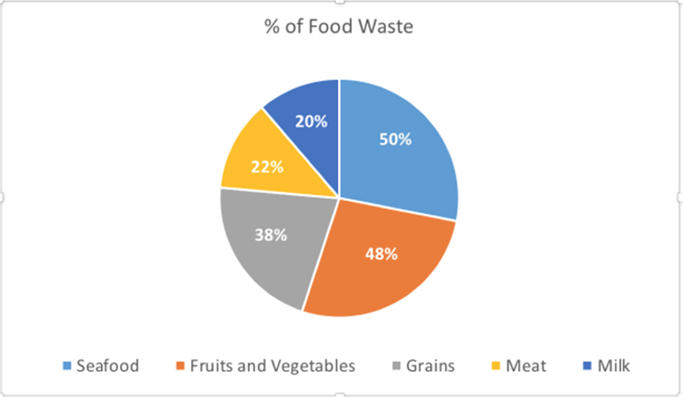

● Because our product is primarily for orphanages, we focused our research and analysis on usability, accessibility, efficiency, high proficiency, and building a solution that will pleasure the user in terms of design.

* The majority of users use Android devices and are familiar with logging into apps such as Gmail, Facebook, and Instagram.
* In our app, the login process should be done in the same way.
* Since the majority of people live in cities.
* They have unrestricted Internet and network bandwidth. As a result, there is no variation in bandwidth.
* Donors use smartphones in the high and medium range. You have unrestricted storage, RAM, and configuration options.

**Chapter 4**

**Design**

We create a food donation software that incorporates various HCI principles. A good interface design must take into account the wants and concerns of the intended users. As a result, the steps in our app design are as follows.

**4.1 Stakeholder Identification**:

People or organisations who will be affected by the system and who have a direct or indirect influence on the system requirements" are referred to as stakeholders. In the context of food donation, this could include restaurant employees and food shelter staff, for example.

In our Donating app, we specifically identify stakeholders such as NGO (non-governmental organisation) managers, café owners, grocery store owners, and other jobs with similar age and ethnicity demographics. The majority of them are from the New Jersey-New York area, so they're easy to get to for visits.

**4.2 Social Interaction for Interface Design:**

During the interface design process, we interview stakeholders for comments, ideas, and opinions based on the app's potential usefulness, such as entry fields in the app interface from the perspective of a food consumer versus a food supplier. These fields are needed to lay out the app. It's exciting to see how stakeholders are motivated to use our app, which comes from their own desire to give back! In addition, we conduct ethnographic research. Ethnography is defined in the field of human-computer interaction as the social organisation of activities to study work, notably in the construction of collaborative systems. Direct observation, knowledge of norms and processes, and workflow diagrams are all required. We undertake these tasks and collect relevant ethnographic data during our visits to stakeholder locations, such as the amount of leftover food in a café and critical food qualities such as perishability. We take these considerations into account when designing our app layouts..

**4.3 Conceptual Design Construction:**

Outlining wireframes, or basic mockup designs that will act as blueprints for future development, is a common part of this process. As a result, we create app wireframes based on our own creative ideas, as well as numerous features proposed by stakeholders and data from our ethnographic studies. Based on our ethnographic investigations, our wireframe includes areas such as "storage technique" for the food supplier and "allergy / dietary restrictions" for food customers, as these are important issues, particularly in the United States. A simple outline with entry boxes may be seen in the wireframe.

**4.4 Design Evaluation by Stakeholders:**

Stakeholder feedback on conceptual design wireframes is critical in this HCI approach. Typically, app designs are iterated upon after stakeholder feedback. We provide our stakeholders small tasks to do in order to gain their opinion on the wireframes during our app design evaluation. While exploring the initial concept, the stakeholders' feedback is used to improve the final design of the application. The use of icons, for example, is a form of feedback. These are handled in terms of HCI using the concept of a metaphor, which is defined as a way of visualizing an operation.

Consider the icon of a shopping cart, which we use to arrange products we want to buy on an online buying site. On the app's welcome screen, we also provide a metaphor for the function of selfless service, as well as detailed icons with the food supply and consumer buttons for quick and easy comprehension. Stakeholder feedback produced the following results.

**4.5 Final App Design:**

The ultimate app design in HCI is generally iterative. In a smaller context, it is possible to proceed with just one iteration of design evaluation. In larger systems, numerous iterations may be required until all stakeholders are satisfied (analogous to the spiral model of software development as opposed to the waterfall model). Given that our app is still in the prototype stage, and that we are targeting a small region and clientele for food donation, the final app design is completed in one iteration. This is partly because our stakeholders are extremely cooperative, providing satisfactory assessments on the first try.

**4.6 UML Diagrams**

**1.Use Case-Diagram**

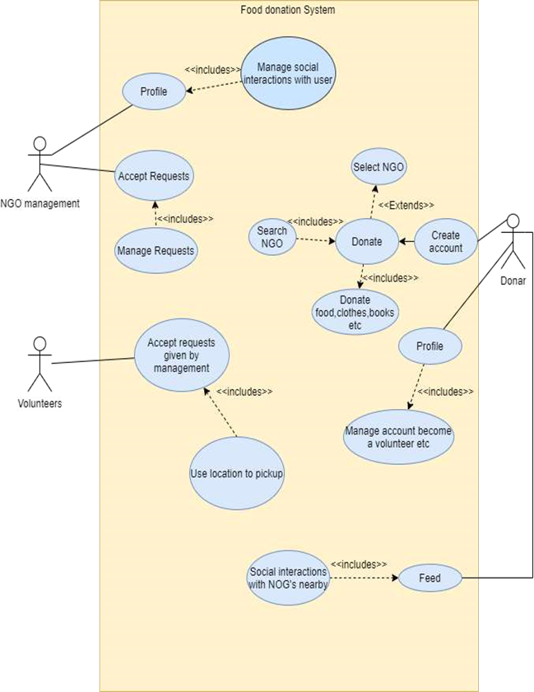

**2.Sequence-Diagram**

**Fig :Sequence Diagram for NGO Management**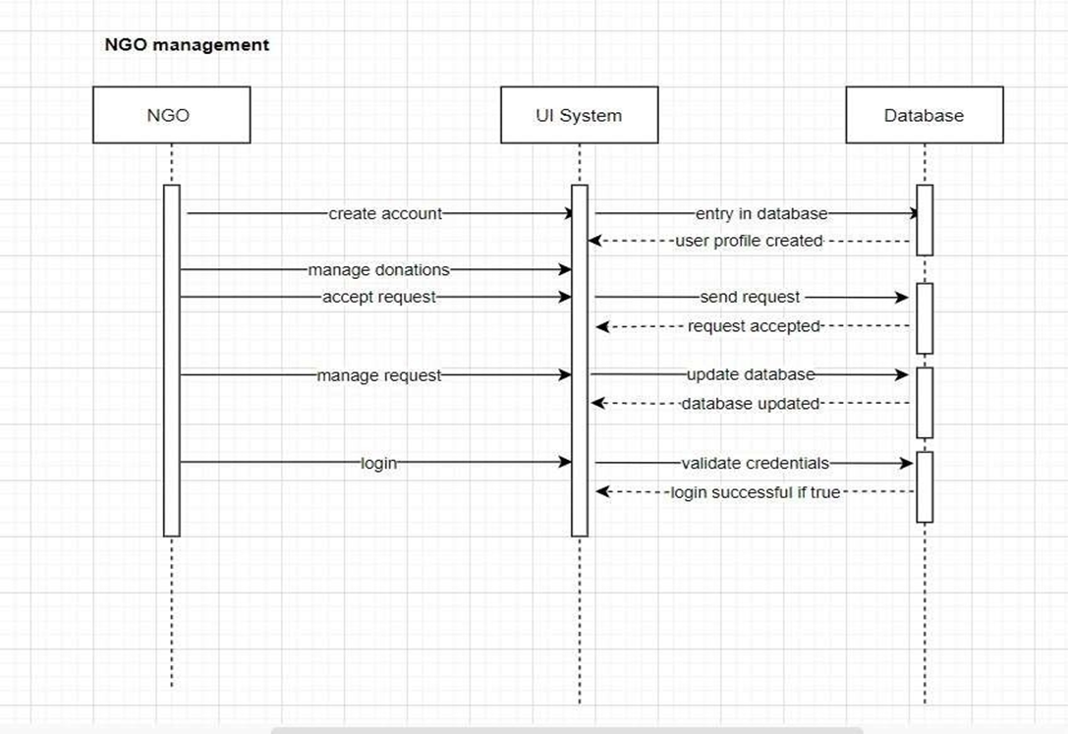

**3. Sequence-Diagram**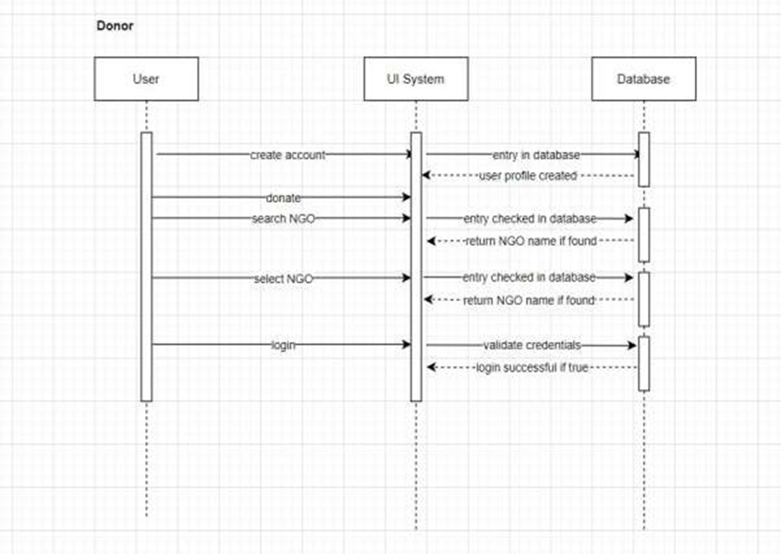

**Fig :Sequence Diagram for Donor**

**4. Sequence-Diagram**

**Fig :Sequence Diagram for Voluntee**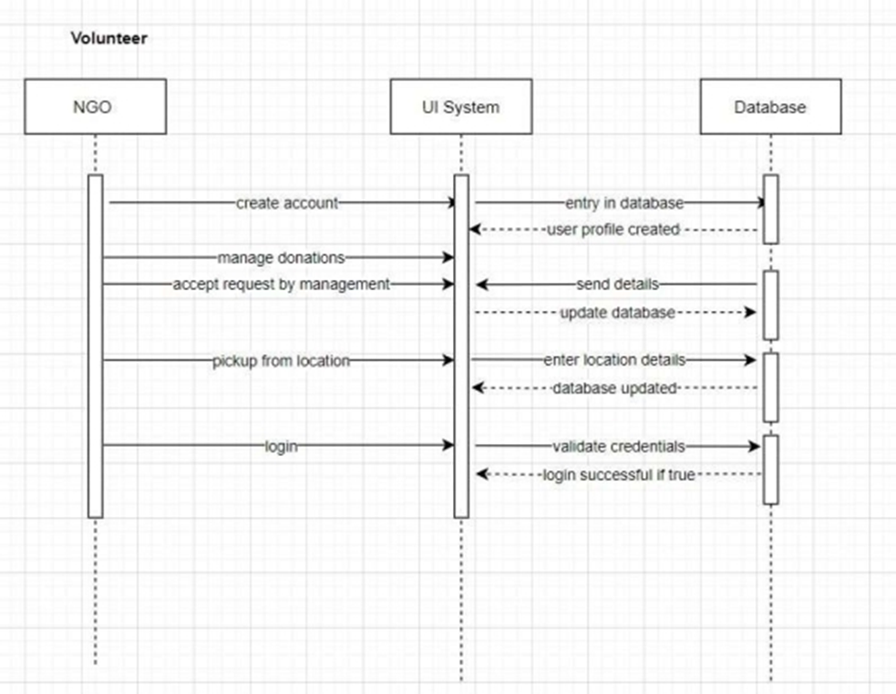

**5. Activity-Diagram**

**Registration Login Volunteer**

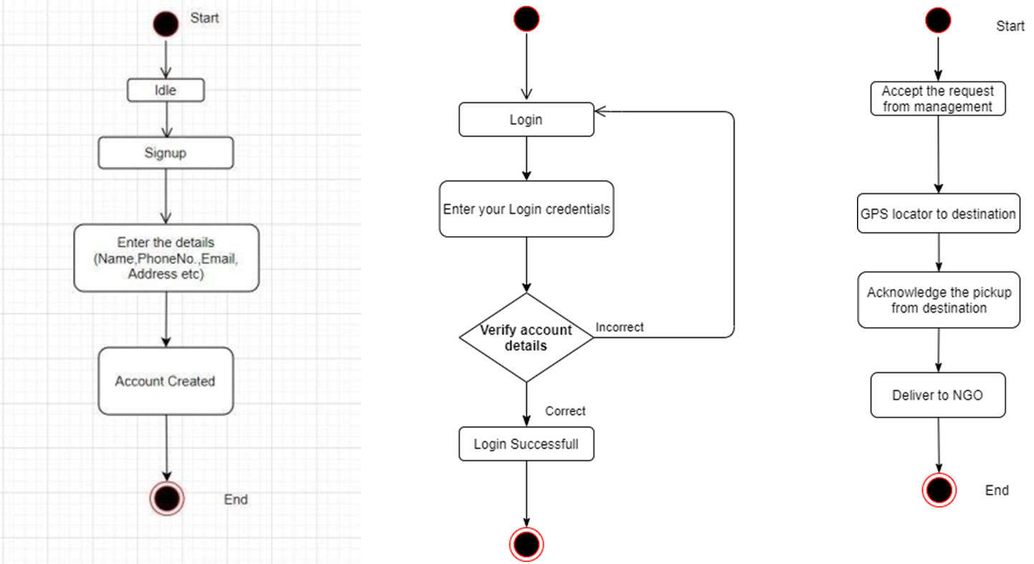

**6. Activity-Diagram**

**NGO Management Donor** 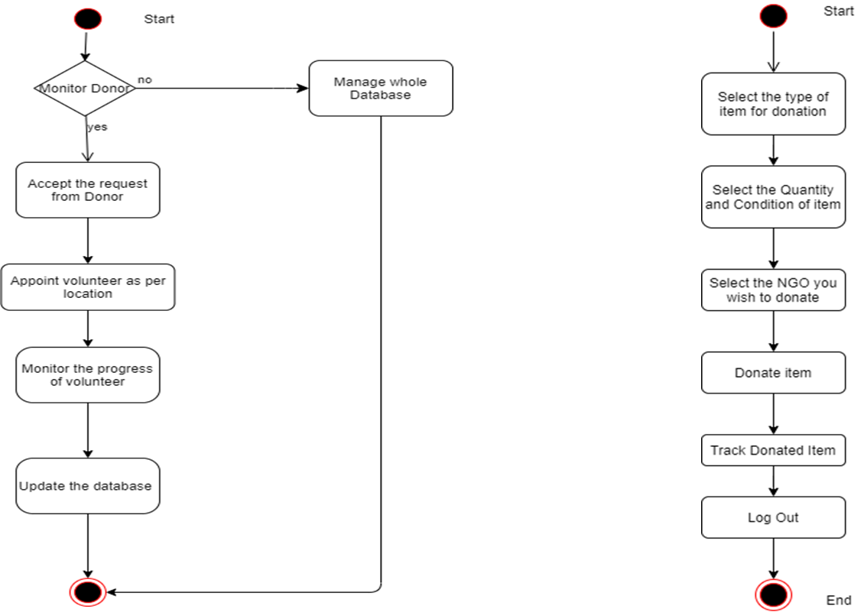

**Chapter 5**

**Implementation**

The Android Platform is used to develop the Donating app. The following are the reasons for adopting Android:

(1) Android Studio offers a variety of not-able capabilities that are both innovative and simple to use; and

(2) we intend to release this app on the Android marketplace via Google Play (where releases are quite feasible for individual developers). Here are some of the Android Studio's most notable features.

Android Studio includes a powerful and feature-rich emulator:

* It uses a Gradle-based build system that is quite versatile.
* It provides a uniform development environment for apps.
* It comes with code generation templates and is easy to integrate with GitHub.
* It comes with a lot of testing tools and frameworks.
* Lint tools are included to detect performance, usability, version compatibility, and other issues.
* It is compatible with C++ and the NDK (Native Development Kit).
* It takes advantage of Google Cloud's built-in functionality, which makes it easier to integrate Google Cloud Messaging with the App Engine.

**Chapter 6**

**Execution Procedure and Testing**

The overall response to the prototype Donating app is quite positive, according to both objective and subjective evaluations. This software is clearly valuable to survey respondents, who believe it is especially useful during the COVID-19 outbreak and its aftermath. The verbal feedback from the surveys is quite encouraging, since it reflects a favorable first response and anticipation for the app's eventual release. It's great that some people recommend ways to improve things.

For the recovered congruent studies, we provide descriptive statistics such as publication year, publishing source, educational institution researched, geographic scope of each study, and theoretical framework. According to year-by-year publications, there was little research on food waste at educational institutions' food service enterprises until 2012, after which the number of studies increased, peaking at 15 in 2019. The findings were also published in several nutrition and waste management journals. It displays the number of studies that have been conducted on each type of educational institution (e.g. school versus university). It lists the countries where school and university studies were conducted. Surprisingly, the examined research used seminal ideas to propose a hypothesis and/or discuss findings.

A software defect occurs when the software programme differs or diverges from the end user's or original business requirements. A software defect is a coding error that causes inaccurate or unexpected output from a software programme that does not fulfil its intended purpose. Testers may come upon such issues while carrying out test cases. These two terms have a thin line between them; both are problems that must be fixed in the industry, and some testing teams interchange them. When testers run the test cases, they may encounter results that aren't exactly what they expected. A variation in test results is defined as a Software Defect. Other companies use terms like issues, problems, bugs, and incidents to describe these defects or variants.

### 6.1 Software Application Coding

Consider using off-the-shelf components that can be reused. During the coding phase of an algorithm, COTS or previously written code can be used. It's crucial in the rest of the software design and development process.

To properly integrate all of the configuration's components;

To have a collection of elements, such as the specification of reused elements, the identification of component interfaces, and the identification of usage assumptions, that can show that an element can be used in this application.

The assumptions for use must allow for the component's correct functionality as part of the overall system.

These assumptions should include the following:

* limits imposed by hardware (memory size, cache size, number representation, addressing, CPU load, and so on);
* Limitations imposed by time;
* constraints imposed by safety (safety level, safety requirements, etc.).

The programmes and/or libraries that have been reused must be specified (name, reference, and version) and proved to be utilized in a similar context. The identification of the functions that are or are not used, the limits of usage, and the impact of existing anomalies must all be used to demonstrate that the operating environment is similar.

### 6.2 Including the machine learning algorithm into the system.

**Algorithm Understanding**

Implementing a machine learning algorithm will provide you with a thorough understanding of how it works. This understanding can also assist you in internalizing the algorithm's mathematical description by conceiving of vectors and matrices as arrays, as well as the computational intuitions for transformations on those structures.

When constructing a machine learning algorithm, many micro-decisions must be made, and these decisions are frequently left out of formal method descriptions. Because few individuals take the effort to design some of the more complicated algorithms as a learning exercise, learning and parameterizing these options may swiftly catapult you to intermediate and advanced levels of comprehension of a certain approach.

### 6.3 Testing

Application testing is the process of identifying flaws in any software application by utilizing scripts, tools, or test automation frameworks. It enables teams to deploy bug-free and stable software into the actual world. It also allows teams to detect flaws early in the development process, reducing development time.

Application testing is divided into two phases: frontend (or user interface) testing and backend (or database behavior) testing.

Naturally, application testing may be done in two ways:

**6.3.1 Manual Testing**

During the early stages of development, developers prefer to use the manual testing approach to test specific features.

**6.3.2 Automated Testing**

QAs automate test scenarios from the perspective of end-users to evaluate the usability, functionality, and performance of the software application once it has been fully developed.

There are three basic types of software applications:

1. Web-applications
2. Apps for mobile devices (Android, iOS)
3. Applications for the desktop

**Chapter 7**

**Results & performance Evaluation**

The Food Donation Project System is on a mission to eliminate hunger and food waste in order to create a world free of hunger. According to the most recent survey, 1.3 billion tons of food are discarded each year. Furthermore, leftovers account for one-third of the food consumed. The goal of this initiative is to decrease the quantity of food that is wasted and given to those in need.

The success and ultimate end of our project needs a great deal of direction and support from a large number of individuals, and we are really lucky to have received this during the course of my project work. We owe all we've accomplished to their direction and aid, and we'll never forget to thank them.

**Chapter 8**

**Conclusion and future work**

We would like to conclude that our project will help the poor by connecting them with donors through the use of NGOs as gateways, who will carry out the task with the assist of the application that we will provide. Our application will seek to address issues such as donor awareness and transparency in the donation process, acting as a connection between needy people and those who can help.

The unconsumed food from the functions and gatherings can be donated easily. The donation's visual impact can have a good influence on the users. The food donation project's primary goal is to reduce wastage while also feeding the hungry. The user who donates the food and the person/organization who receives the food are both targeted by the application.

**Appendix**

**Program Listing Code**

**Algorithm 1: Input-Output Execution in the Donating App**

INPUT:Food data is entered by supplier S.

OUTPUT:Display of food data to the consumer C

D: food data, I data index, f: data field, t: time, d: distance

Accept S's login credentials (username and password) via the Android frontend.

Examine the login process using the Java backend.

If S.login == invalid

Prepare a report (Invalid username or password)

Else Begin Data Entry /* shown for one instance only */

S uses the Android Frontend to get into D[i].

For all fields D[i].f є D[i]

CSP through Java Backend is used to check limitations.

If constraint.violation == True, the constraint is violated.

Report (Error)

Else add D[i] to SQLite KB via Java backend

End Data Entry

Accept C's login credentials (username and password) via the Android frontend.

Examine the login process using the Java backend.

If C.login == invalid \sReport (Invalid username or password)

Else Start a Data Search /* this is only for one instance */

C searches D for (t: t1… tn, d: d1… dm) via Android frontend

Using CSP with a Java backend, apply constraints (t, d).

Execute a SQLite KB query on D for (t, d) using the Java backend.

Display (D[i]) via Android frontend if D[i] for (t, d) exists.

Otherwise, show (No food items available)

End Data Search

**List of Abbreviations and Nomenclature**

| SMS  HTTP  CPU  DBMS  COTS  API  ML  NGO  UML  UI  IOS | Short Message Services  Hypertext Transfer Protocol  Control Processing Unit  Database Management System  Commercial off-the-shelf  Application Programming Interface  Machine Learning  Non-Governmental Organization  Unified Modeling Language  User Interface  iPhone Operating System |
| --- | --- |

**List of Figures**

| **Figures** | **Description** | **Page No** |
| --- | --- | --- |
| Fig 1 | Login, Registration, Home Pages | 39 |
| Fig 2 | Donating Food, Money, and Clothes | 39 |
| Fig 3 | Payment and Thanking Pages | 40 |

**Screenshots:**

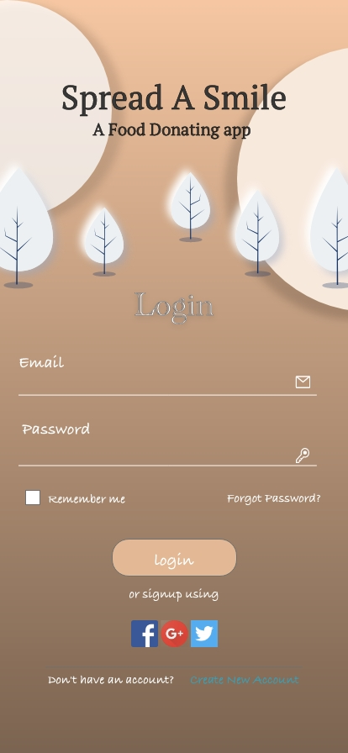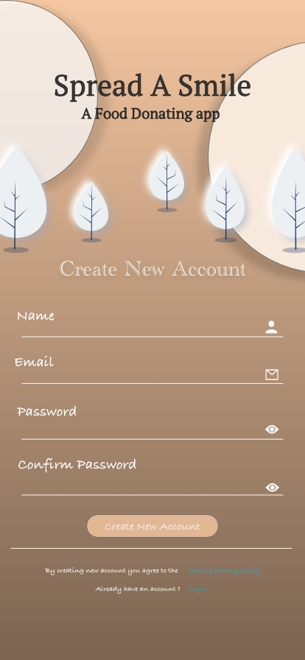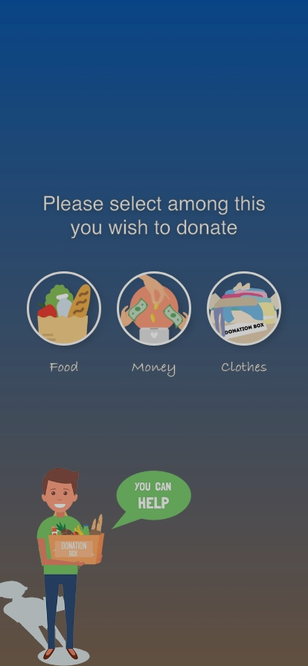

**Fig 1: Login, Registration and Home Pages**

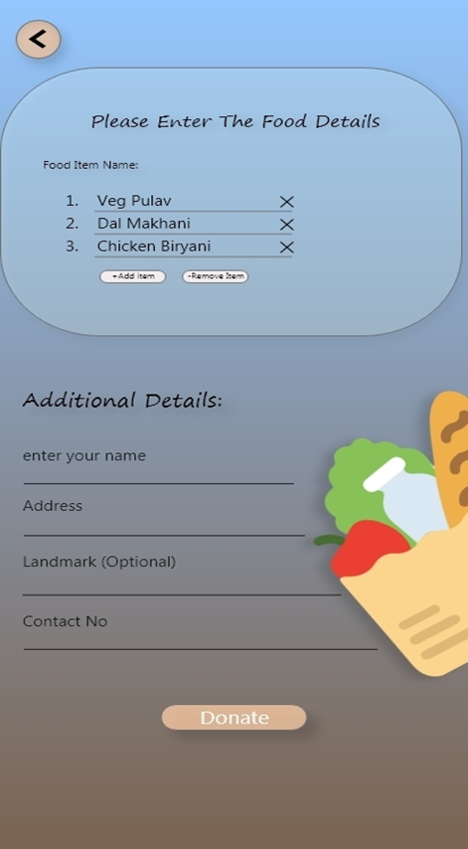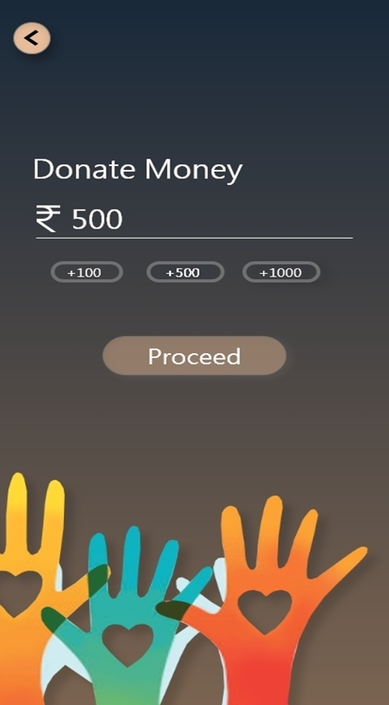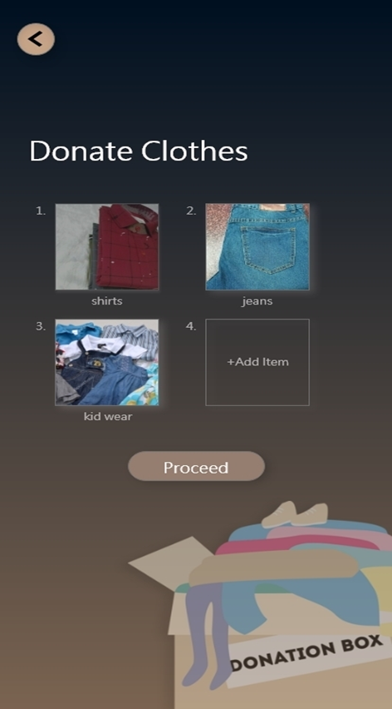

**Fig 2: Donating Food, Money and Clothes Pages**

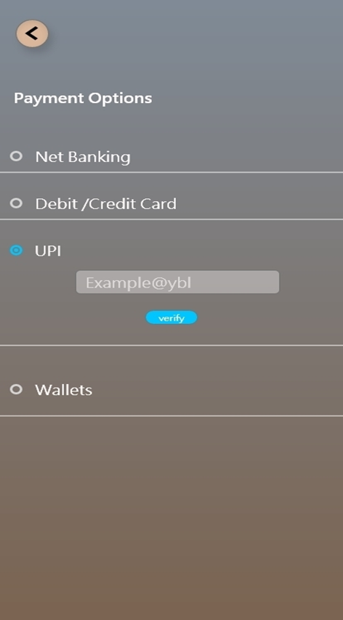

**Fig 3: Payment and Thanking Pages**

**References**

1. Android Development for Beginners - freecodecamp.org-YouTube

2. Free Adobe XD Tutorial: user Experience Design Course - Bring Your Own Laptop - YouTube

3. Timesofindia.Indiatimes.com

4.www.indianexpress.com

5.https://www.foodfororphans.org/

6.https://www.wfp.org/countries/india